

Table of Contents

Introduction 1

References 3

Course Contents 3

GitHub List Commits 3

What Even Is Webpack 3

Installing and Running Webpack and Webpack-CLI 5

Install Webpack 7

Webpack Default Configuration 9

# Introduction

**Webpack** is a powerful tool used in web development. Let’s dive into what it does:

1. **Module Bundler**:
   * **Webpack** is primarily a **module bundler**.
   * Its main purpose is to bundle JavaScript files (and other assets) for usage in a web browser.
   * Imagine it as a way to package all your code and assets into a single file or a few files that the browser can efficiently load.
   * It takes your project’s various modules (JavaScript files, CSS, images, etc.) and combines them into a single output file (or multiple files) that can be served to the browser.
2. **JavaScript Transformation and Optimization**:
   * Besides bundling, **Webpack** can also perform transformations on your code.
   * It can transpile modern JavaScript (ES6+) into older versions (ES5) using tools like Babel.
   * It optimizes your code by minifying it (removing unnecessary whitespace and renaming variables) to reduce file size.
   * This results in faster loading times for your web application.
3. **Configuration-Driven**:
   * **Webpack** uses a configuration file called webpack.config.js.
   * In this file, you define how your project should be bundled.
   * You specify entry points (where the bundling process starts), output paths, loaders (for handling different file types), and plugins (for additional tasks like code splitting or generating HTML files).
4. **Loaders and Plugins**:
   * **Loaders** allow **Webpack** to process different types of files (e.g., CSS, images, fonts) and convert them into valid modules.
   * **Plugins** enhance the bundling process by performing additional tasks.
   * For example, the **HTMLWebpackPlugin** generates an HTML file with the bundled JavaScript automatically injected.
5. **Code Splitting**:
   * **Webpack** supports code splitting, which means breaking your bundle into smaller chunks.
   * This is useful for optimizing performance by loading only the necessary parts of your application when needed (e.g., lazy loading routes).
6. **Development and Production Modes**:
   * **Webpack** has different modes: **development** and **production**.
   * In development mode, it provides features like source maps for easier debugging.
   * In production mode, it aggressively optimizes your code for better performance.
7. **Community and Documentation**:
   * The **Webpack** community is active, and there are plenty of plugins and loaders available.
   * The official documentation is comprehensive and provides guides, concepts, and examples to get you started.

In summary, **Webpack** is a versatile tool that simplifies managing your project’s assets, optimizes your code, and makes web development more efficient. If you’re new to it, check out the [Getting Started guide](https://webpack.js.org/guides/getting-started/) to explore its features!

# References

[Learn Webpack - Full Tutorial for Beginners](https://www.youtube.com/watch?v=MpGLUVbqoYQ&list=WL&index=3&t=2341s)

[Colt Steele's YouTube channel](https://www.youtube.com/channel/UCrqAGUPPMOdo0jfQ6grikZw)

[Colt Steele Github Code](https://github.com/Colt/webpack-demo-app)

Course Contents

⌨️ (0:00:00) What Even Is Webpack??

⌨️ (0:08:12) Installing and Running Webpack and Webpack-CLI

⌨️ (0:22:18) Imports, Exports, & Webpack Modules

⌨️ (0:29:58) Configuring Webpack

⌨️ (0:38:57) Loaders, CSS, & SASS

⌨️ (0:53:55) Cache Busting and Plugins

⌨️ (1:07:13) Splitting Dev & Production

⌨️ (1:17:13) Html-loader, File-loader, & Clean-webpack

⌨️ (1:28:17) Multiple Entrypoints & Vendor.js

⌨️ (1:34:45) Extract CSS & Minify HTML/CSS/JS

# GitHub List Commits

1. [Initial app code, no webpack](https://github.com/johncusey/webpack-demo-app/commit/b96a9dbce0d4abbf156612ccb23e4be74d6fd313) (What Even Is Webpack??)
2. [Break code into separate scripts, no webpack](https://github.com/johncusey/webpack-demo-app/commit/dd5492493336955c66c8960d4e50d76297199fbb) (Installing and Running Webpack and Webpack-CLI)

# What Even Is Webpack

Webpack Official Website:

Webpack Official GitHub Website:

The file structure webpack generates.

Command for building a React Application.

The file structure Webpack generates

# Installing and Running Webpack and Webpack-CLI

Example code base used by Colt Steele

The file structure of the starter project.

Screen shot the the appliction

The coding structure after refactoring the code into many files for Webpack to bundle.

You have to include all the JavaScript files in script tags. If you use Webpack you can eliminate all these script tags.

## Install Webpack

1) Install Package Json

Install package json file run the following command. The package.json file is a crucial part of Node.js projects. Here’s what it does:

1. **Metadata and Descriptive Information**:
   * It’s a **JSON file** residing in the root directory of your project.
   * Contains both **human-readable metadata** (like project name and description) and **functional metadata** (such as package version number).
   * Helps people discover your package by providing a **description** and **keywords**.
   * [Specifies the **project homepage URL** and the **issue tracker URL** where users can report issues1](https://docs.npmjs.com/cli/v6/configuring-npm/package-json/)[2](https://heynode.com/tutorial/what-packagejson/).
2. **Dependency Management**:
   * Lists the **dependencies** required by your application.
   * When you run npm install, it installs the dependencies specified in this file.
   * Helps manage versions and ensures consistent behavior across different environments.
3. **Versioning**:
   * The **name** and **version** fields together form a unique identifier for your package.
   * Changes to the package should correspond to changes in the version.
   * If you plan to publish your package, these fields are **required**.
   * [If not publishing, they are **optional**1](https://docs.npmjs.com/cli/v6/configuring-npm/package-json/).
4. **License Information**:
   * Specify a **license** for your package (e.g., BSD-3-Clause or MIT).
   * Helps users understand how they can use your package.
   * [Use SPDX license identifiers or custom strings1](https://docs.npmjs.com/cli/v6/configuring-npm/package-json/).
5. **Scripts and Commands**:
   * Define custom **scripts** (e.g., build, test, start) that can be executed using npm run.
   * Makes it easy to automate common tasks during development.
6. **Other Details**:
   * You can include a **file** named <filename> at the top level of the package.
   * [Deprecated styles like license objects are now replaced with SPDX expressions1](https://docs.npmjs.com/cli/v6/configuring-npm/package-json/)[3](https://nodesource.com/blog/the-basics-of-package-json/).

In summary, package.json is your project’s **manifest**, containing essential information for Node.js, npm, and JavaScript development.

**$ npm init -y**

2) Install Webpack and Webpack CLI



**npm install --save-dev webpack webpack-cli**

3) Changing script in Package Json

# Webpack Default Configuration

Have Webpack bundle the project by using the script in the Package Json. The **“scripts”** property allows you to define custom commands that can be executed.



If you see the following error you need ***index.js*** file in the ***src folder***.



Solution:

After run Webpack you get the following message. The ***index.js*** is the entry point

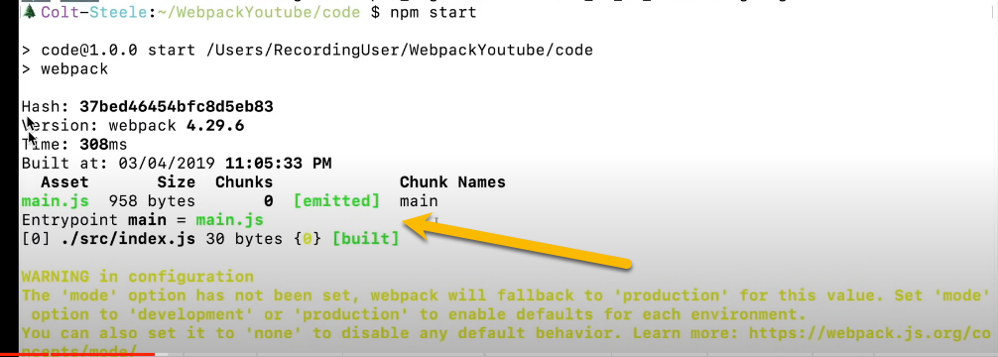

Webpack create the **dist** folder with ***main.js***

You need to added ***main.js*** to your ***index.html*** file.

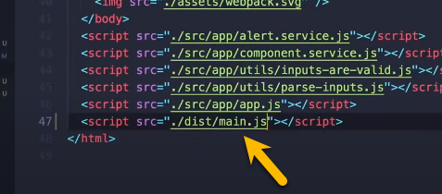

Now you can see calling the ***index.js*** entry point file.

